**Assignment 7 – Part 1  
p565 Set 9.2 - 11.c, 14.c,e, 17, Set 9.3 - 5, 24, 33-e,f**

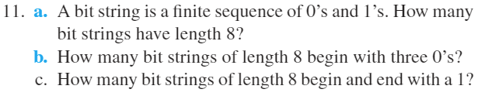

**11.c.)**

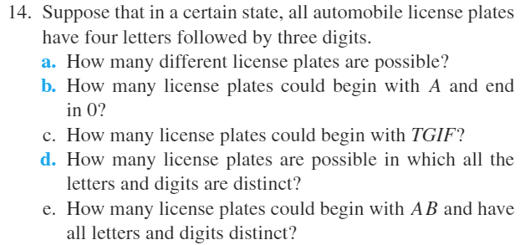

**14.c.)**

**14.e.)**

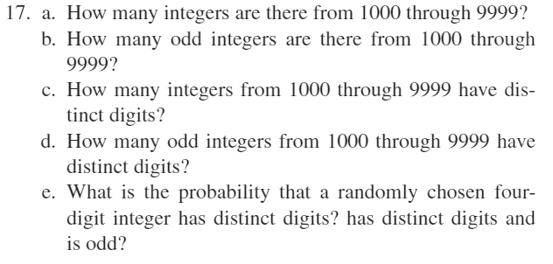

**17.a.)**

**17.b.)**

**17.c.)**

**17.d.)**

**17.e.)**

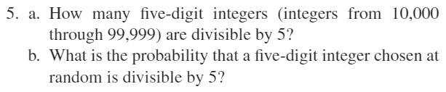

**5.a.) integers are divisible by 5**

**5.b.) Total possible five-digit integers from 10,000 to 99,999:**

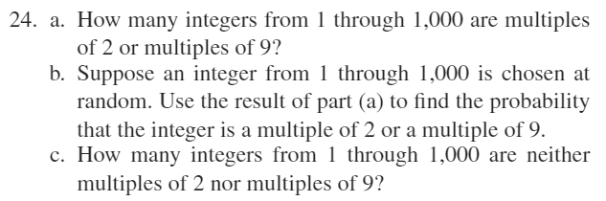

**24.a.) Let A = the set of all integers from 1 through 1000 that are multiples of 2  
Let B = the set of all integers from 1 through 1000 that are multiples of 9  
 the set of all integers from 1 through 1000 that are multiples of 2 or multiples of 9  
 the set of all integers from 1 through 1000 that are multiples of both 2 and 9  
 the set of all integers from 1 through 100 that are multiples of 18.**

**24.b.)**

**24.c.)**

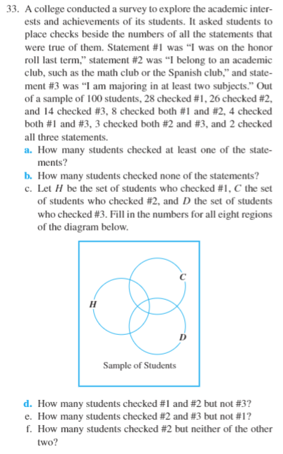

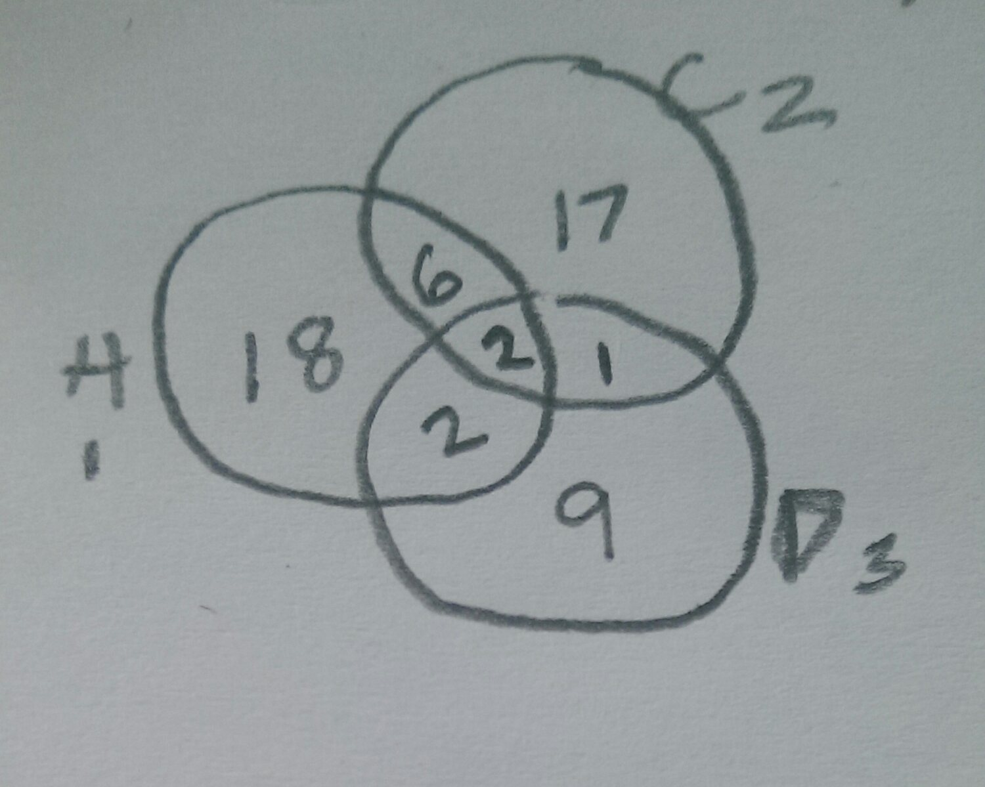

**33.e.) 1**

**33.f.) 17**